
RAMAIAH
Institute of Technology
USN | 1 | M | S

(Autonomous Institute, Affiliated to VTU)
(Approved by AICTE, New Delhi & Govt. of Karnataka) Accredited by NBA & NAAC with ‘A’ Grade

SEMESTER END EXAMINATIONS – JANUARY 2020

Programs | : | B.E. : Common to all Programs | Semester | : | I/II
Course Name | : | Basic Civil Engineering and Mechanics | Max. Marks | : | 100
Course Code | : | CV14/CV24/CV101/CV201 | Duration | : | 3 Hrs

Instructions to the Candidates:
- Answer one full question from each unit.

 |  | UNIT- I
1. | a) | List out the different branches of civil engineering. Explain in brief about each of these branches. | CO1 | (10)
 | b) | Define concrete. List out the advantages of concrete over other building materials. What are the applications of concrete as a construction material? | CO1 | (10)
2. | a) | Explain in brief the scope of civil engineering. Explain the role of civil engineers in the society. | CO1 | (10)
 | b) | Explain briefly the advantages and disadvantages of each of the following building materials: i) PCC ii) RCC iii) PSC iv) Structural Steel. | CO1 | (10)
 |  | UNIT- II
3. | a) | Explain with an example:  - Principle of transmissibility of forces  - Resolution of forces  - Equilibrant of a system of forces. | CO2 | (10)
 | b) | A coplanar non concurrent force system is acting on a lamina as shown in Fig 3(b). Determine the resultant with respect to point A.  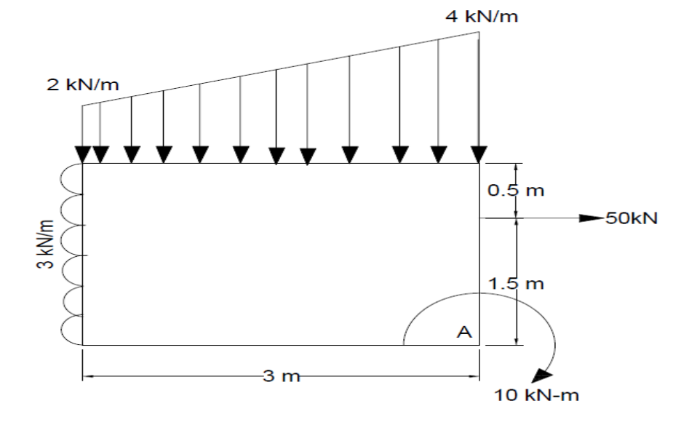  Fig 3(b) | CO2 | (10)
4. | a) | Two Cables are connected at A and B as shown in Fig 4(a). A force of 20kN is applied at C. Determine the forces in the cables along AC and CB.  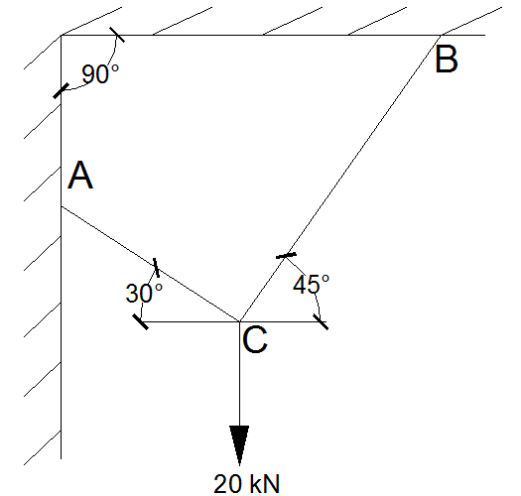  Fig 4(a) | CO2 | (10)
 | b) | Determine the magnitude, direction and position of the resultant of forces about O as shown in Fig 4(b).  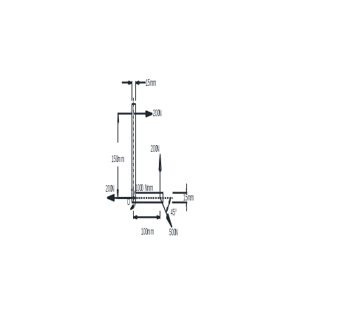  Fig 4(b). | CO2 | (10)
 |  | UNIT- III
5. | a) | Define free body diagram? Explain with an example. | CO3 | (05)
 | b) | Two spheres each of weight 1000N and of radius 25cm rests in a horizontal channel of width 90cm as shown in Fig. 5(b). Find the reactions at the points of contact A, B, C and D.  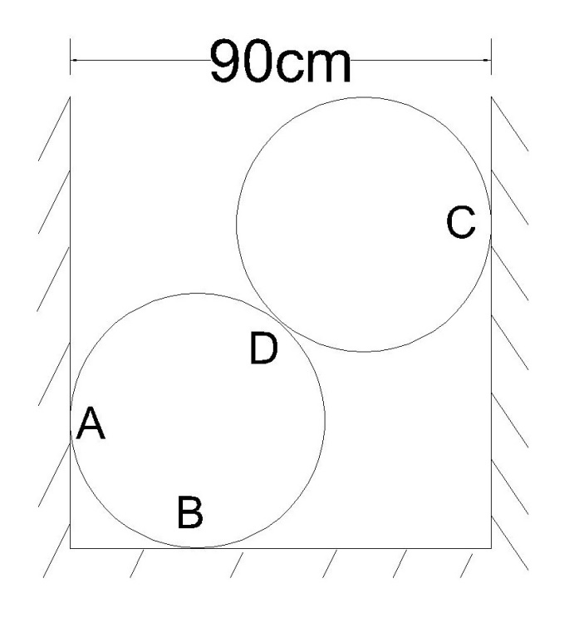  Fig. 5(b) | CO3 | (15)
6. | a) | Differentiate between statically determinate and indeterminate structure with example. | CO3 | (06)
 | b) | Find the magnitude of anti-clock wise couple M to be applied at D so that reaction at F will be 35kN upwards. Also find the reaction at support B for beam shown in Fig. 6(b).  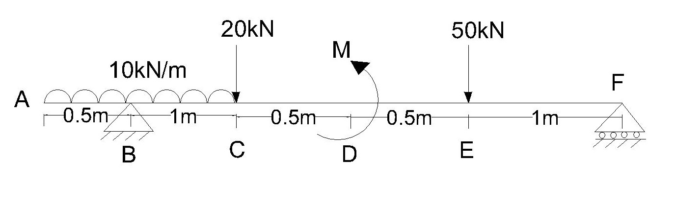  Fig. 6(b) | CO3 | (14)
 |  | UNIT- IV
7. | a) | Determine the position of centroid for the lamina with a circular cut-out shown in Fig. 7(a).  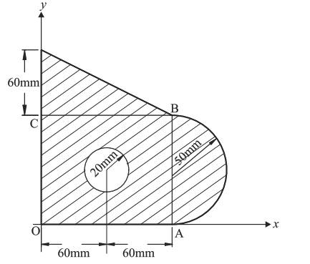  Fig. 7(a). | CO4 | (15)
 | b) | Obtain the centroid of a semi‐circular lamina of Radius “R” by the method of integration. | CO4 | (05)
8. | a) | Determine the moment of inertia of the shaded area about an axis normal to the symmetrical axis. (2) - (2) as shown in Fig. 8(a).  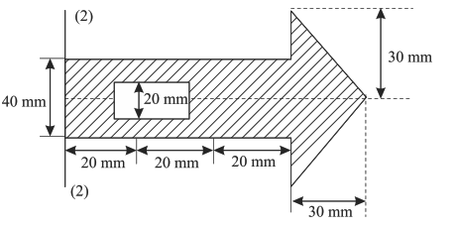  Fig. 8(a). | CO4 | (15)
 | b) | State and prove perpendicular axis theorem. | CO4 | (05)
 |  | UNIT- V
9. | a) | Show that angle of friction is equal to the angle of repose for any two surfaces in contact. Also derive the equation for the path of the projectile. | CO5 | (10)
 | b) | A stone is dropped from the top of cliff of height 120m. After 10s another stone is thrown down which strikes the first stone at the foot of the cliff. Find the velocity with which the second stone was thrown. | CO5 | (10)
10. | a) | Find the least value of “P” required to cause the system of block shown in Fig.10(a) to have impending motion to the left. The coefficient of friction for all contact surfaces is 0.2.  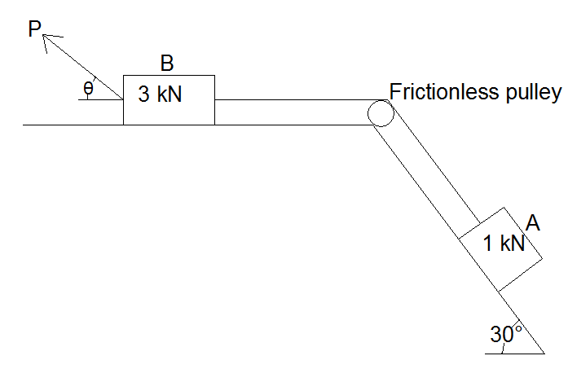  Fig.10(a) | CO5 | (10)
 | b) | A cricket ball is thrown by a player from a height of 2.0m above the horizontal ground at an angle of 30° to the horizontal and with the velocity of 12m/sec. the ball hits the wicket at a height of 0.6m above the ground. How far is the player from the wicket? | CO5 | (10)

****************

